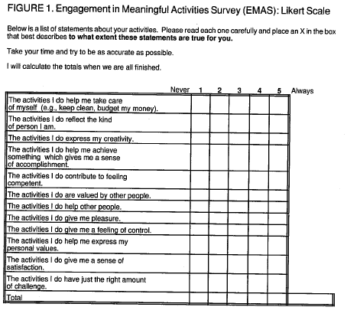

Below is a list of statements about your activities. Please read each one carefully and mark which best describes to what extent these statements are true for you.

Take your time and try to be as accurate as possible.

Never 1 2 3 4 5 Always

The activities I do help me take care of myself (e.g. keep clean, budget my money).

The activities I do reflect the kind of person I am.

The activities I do express my creativity.

The activities I do help me achieve something which gives me a sense of accomplishment.

The activities I do contribute to feeling competent.

The activities I do are valued by other people.

The activities I do help other people.

The activities I do give me pleasure.

The activities I do give me a feeling of control.

The activities I do help me express my personal values.

The activities I do give me a sense of satisfaction.

The activities I do have just the right amount of challenge.